MAGNETISM
Magnetism is the phenomenon of attracting magnetic substances like iron, nickel, cobalt, etc. A body possessing the property of magnetism is called a magnet.
Properties of a Magnet
- A magnetic pole is a point near the end of the magnet where field lines are concentrated.
- A freely suspended magnet aligns itself along North – South direction.
- It attracts magnetic substances.
- Unlike poles attract and like poles repel each other.
- Magnetic poles always exist in pairs. i.e. Poles cannot be separated.
- A magnet can induce magnetism in other magnetic substances
Magnetic Field
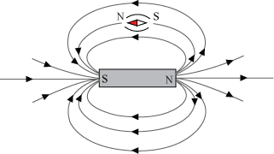
- It is a vector field that describes the magnetic influence.
- Magnetic field can be created by moving charge or magnetized materials.
- Magnetic field is represented by the lines of force moving from north pole to south pole of magnet.
- Moving charge experience a force and magnetic dipole experience torque in a magnetic field.
Magnetic Field Sources
Magnetic flux (ϕ_{B})
- Magnetic flux (φ_{B}) is the component of field lines normal to a surface.
- It is the amount of magnetic field passing through a surface.
- It is a scalar quantity with unit –Weber (Wb)
Magnetic Induction/ Magnetic Flux Density (B)
- Magnetic Induction (B) at any point is defined as the magnetic flux passing through unit area around the point.
OR
- The magnetic flux density is denoted as B ̅ and is defined as the total magnetic lines of force or the magnetic flux per unit area in a plane that is perpendicular to the direction of the magnetic field.
- It is a vector quantity with Unit –Weber/m² or Tesla (T)
Magnetising Field /Magnetic Field Strength (H)
- It represents magnetic field produced by external current or magnet. It is the force experienced by a unit north pole of one Weber strength when placed at any point in the magnetic field.
- It does not include the response of medium to the field.
- The magnetic field strength or magnetic field intensity gives the quantitative measure of weakness or strength of the magnetic field.
Gauss’ Law for Magnetic Flux Density
The total magnetic flux through a surface is component of field lines normal to a surface and is given by
where integral is over a closed surface (S) and ds is a vector, whose magnitude is the area of an infinitesimal piece of the surface S, and whose direction is the outward, pointing normal to surface.
Gauss’ Law states that the magnetic field B has divergence equal to zero.
The differential form for Gauss's law for magnetism is:
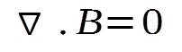
where ∇ denotes divergence and B is the magnetic field.
The integral form of Gauss's law for magnetism is
This means
- Number of field lines entering a surface is equal to that leaving it. I.e. magnetic lines of force always form closed loops.
- Magnetic monopoles do not exist.
Ampere’s Circuital Law
Ampere’s circuital law states that line integral of magnetic field forming a closed loop around the current carrying conductor, in the plane normal to the current, is equal to the μ_{o} times the net current passing through the close loop.
Proof
Consider cross section of a current carrying conductor. Current is directed outwards.
Magnetic field at a distance r from the conductor is given by Biot Savart’s law;
Since radius ‘r’ is a constant around the Amperian loop, magnetic field (B) will be a constant throughout the loop.
This means that line integral of magnetic field forming a closed loop around the current carrying conductor is dependent only on current and is independent of the radius of the loop.
If there are multiple current carrying conductors in the loop, then algebraic sum of the currents need to be taken into account. For ex; if there are three current carrying conductors, then
The condition does not always mean that the current is zero. It could be because of the condition that net current through all the carriers is zero.
Faraday’s Law
Faraday's law states that the EMF is given by the rate of change of the magnetic flux:
where ε is the electromotive force (EMF) and Φ_{B} is the magnetic flux.
Lenz’s law:

Magnetisation & Magnetic Susceptibility
Magnetisation is the density of permanent or induced magnetic dipoles in a material
Magnetic Susceptibility is the degree of magnetisation in response to an applied field
Magnetic Permeability
Magnetic permeability (μ) is the ability of a magnetic material to support magnetic field development in it.
OR
Ratio of magnetic flux density B established within the material to the magnetic field strength H of the magnetizing field.
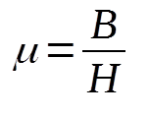
The greater the magnetic permeability of the material, the greater will be the conductivity for magnetic lines of force, and vice versa. SI unit of magnetic permeability is Henry per meter.
Relative Permeability
B is the magnetic induction in a material placed in a magnerising field (H).
where μ is the permeability of material
B_{o} is the magnetic induction at the same place, when material is removed.
where μ₀ is the permeability of free space
Relative permeability is
Magnetic Properties in Materials
Depending on the interaction with magnetic field and the effect of temperature, materials are classified into different groups.
Diamagnetism
- Diamagnetic substances are composed of atoms which have zero net magnetic moment.
- When exposed to a field, a negative magnetization is produced and thus the susceptibility is negative.
- They tend to move from region of strong magnetic field to weak field, when placed n a non uniform magnetic field.
- They are weakly repelled by a magnet.
- Susceptibility is independent of temperature
- Relative permeability is less than unity.
- Diamagnetism is a fundamental property of all matter & it is usually very weak.
- Ex: quartz, calcite, water, bismuth, antimony, gold, silver.

Paramagnetism
- Paramagnetic substances are composed of atoms or molecules which have a net magnetic moment in the absence of external filed.
- When exposed to a field, a positive magnetization is produced. Magnetisation varies proportional to external magnetic field and is inversely proportional to the temperature.
M is the magnetization
B is the magnetic field, measured in Tesla
T is absolute temperature, measured in Kelvin
C is a material-specific Curie constant
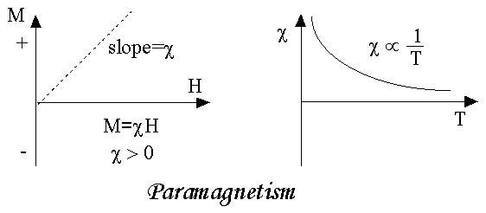

- Susceptibility is small and positive.
- Susceptibility varies inversely with temperature and substance obeys Curie Law.
- Relative permeability is greater than unity.
- They tend to move from region of weak magnetic field to strong field, when placed in a non-uniform magnetic field.
- They are weakly attracted by a magnet.
Ex: Lithium, magnesium, oxygen, copper, chromium, platinum.
Ferromagnetism
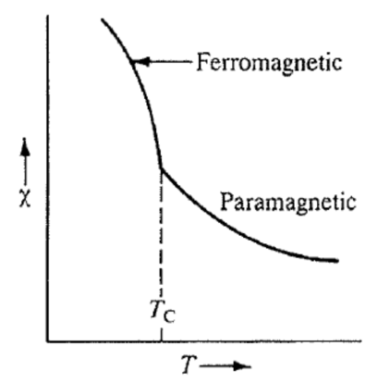
- Ferromagnetic substances are composed of atoms or molecules which have a net magnetic dipole moment in the absence of external filed.
- When exposed to a field, magnetic field lines are highly concentrated within the material resulting in a positive magnetization.
- Susceptibility is large and positive and varies inversely with temperature.
T is absolute temperature, measured in Kelvin
T_{c} is Curie temperature
C is a material-specific Curie constant
- All ferromagnetic materials become paramagnetic above a temperature called Curie temperature
- Relative permeability is greater than unity.
- Permeability is greater than 1.
- Exhibit the phenomenon of Hysterisis.
Ex: Iron , Nickel, Cobalt, Steel , Alnico
Hysterisis
When a magnetic field is applied, ferromagnetic material is magnetized in one direction. When this field is withdrawn magnetization do not relax back to zero. This retained magnetisation is known as retentivity of the material. It must be driven back to zero by a field in the opposite direction. This reverse magnetic field is called the coercivity of the material.

If an alternating magnetic field is applied to the material, its magnetization will trace out a loop called a hysteresis loop. The lack of retraceability of the magnetization curve is the property called hysteresis and it is related to the existence of magnetic domains in the material. Once the magnetic domains are reoriented, it takes some energy to turn them back again.

